May 8, 2026
Caliber Home Loans, Inc.
715 S. Metropolitan Avenue
Oklahoma City, OK 73 108
Re: John Doe and Jane Doe Account(s) ending in: -1315
To Whom It May Concern:
On May 8, 2026, the above-named debtor(s) retained this office to file a voluntary petition under Chapter 7 of the U.S. Bankruptcy Code, in the U.S. Bankruptcy Court, Central District of California.
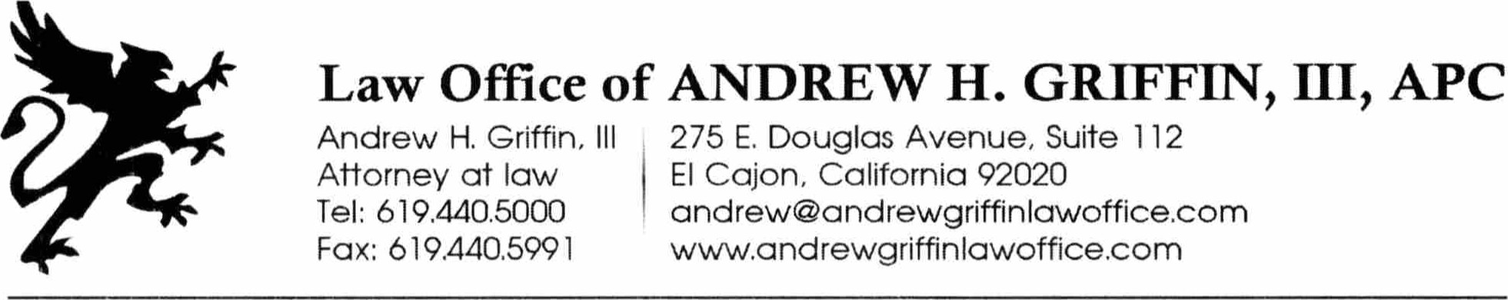
Once the Case is filed under 1 1 U.S.C. Section 362 (a), you may not:
- take any action against the debtor(s) or the debtor(s')'s property to collect any debt;
- enforce any lien on debtor(s')'s real or personal property;
- repossess any property in debtor(s')'s possession;
- discontinue any service or benefit currently being provided to the debtor(s) by you;
- take any action to evict the debtor(s) from his/her residential dwelling.
A violation of these prohibitions may be considered contempt of court and be punished accordingly.
May 8, 2026
Capital One
Attn:Bankruptcy
P.O. Box 30285
Salt Lake City, UT 84 130
Re: John Doe and Jane Doe
Account(s) ending in: -131 1, 7586, -91 I l and -9383
To Whom It May Concern:
On May 8, 2026, the above-named debtor(s) retained this office to file a voluntary petition under Chapter 7 of the U.S. Bankruptcy Code, in the U.S. Bankruptcy Court, Central District of California.
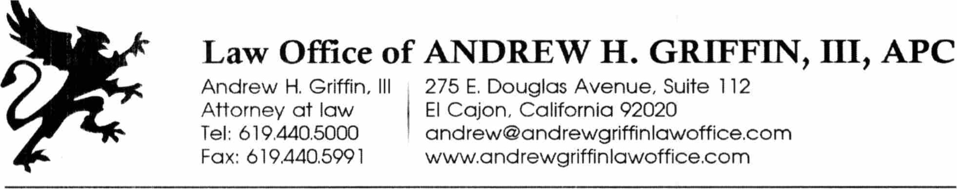
Once the Case is filed under I I U.S.C. Section 362 (a), you may not:
- take any action against the debtor(s) or the debtor(s')'s property to collect any debt;
  - enforce any lien on debtor(s')'s real or personal property;
  - repossess any property in 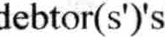 possession;
  - discontinue any service or benefit currently being provided to the debtor(s) by you;
  - take any action to evict the debtor(s) from his/her residential dwelling.
A violation of these prohibitions may be considered contempt of court and be punished accordingly.

